Hello Plainville Families!

I wanted to share with you some resources for PE activities both with and without Internet so that we can stay active during our time at home. I have added some Journal Writing activities and I would love to hear from you! Also, I have other PE resources and I would be more than happy to send them along! Please email me at [tdelgrosso@plainville.k12.ma.us](mailto:tdelgrosso@plainville.k12.ma.us) and feel free to share how you are staying active at home. Thank you and have fun!

~Mrs. DelGrosso

* Here is a Google Doc that I found amazing! Inside, there are drop down menus with activities for each grade level. There are so many to choose from and we are having a blast trying them out!

<https://sites.google.com/nvnet.org/physed/home>

* This Google Doc includes an online Fitness Fun Game Board and some Pre-K activities.

<https://docs.google.com/document/d/1LkLuuWVJYxfRXlKIMjZ2xEHlI6KM0v0QDwaeLprj4GQ/mobilebasic>

* Below is a fitness calendar with daily activities for March. Just click the link for the day and get moving!

<https://docs.google.com/document/d/144YgOCaEO__2cM5AXJyVo-DE3gm9yTx8khVF58i1k6M/mobilebasic>

* Dance Warm-Ups – Get ready because as soon as school is back in session, this is how we will start off our PE classes – I cannot wait!

<https://m.youtube.com/playlist?list=PLyIH-FKI5rzcGwmriK9w463BnSQQHPl7F>

* Cosmic Kids Zen Den – here are 2 examples, but there are many more!

<http://www.youtube.com/watch?v=xUUq0HuSLS0> <http://www.youtube.com/watch?v=so8QN9an3t8>

* Go Noodle – one of my favorites, so many different ways to get moving!

[www.gonoodle.com](http://www.gonoodle.com)

* Exercising the brain and body - I am loving this site with my own kiddos!

<https://fluencyandfitness.com/register/school-closures>

* **Journal Writing Prompts or Walk and Talks:**

**-Compare and contrast your feelings before and after you exercise. What ways did you feel the same? In what ways did you feel different?**

**-How would you describe a person who is enjoying Physical Activity? What would they look like?**

**-Tell me about any Physical Activities that you enjoy doing. Describe why they are your favorites?**

**-Write a story or draw a picture about your favorite Physical Education class.**

I cannot wait to hear about your adventures! The following pages have some ideas about how to stay active. All you need is a little space and a positive attitude. I hope you enjoy them as much as I do!

**-Yoga and Mindfulness Activity – Breathing Bags**

Lay down on a yoga mat/something similar on your back in a comfortable position. Place a beanbag or your hands gently on your belly. Close your eyes and focus on your breathing, inhale through your nose and exhale through your mouth. Stay focused and mindful of the position of the beanbag (or hands/similar object) on your belly. Is it moving with your breath or is it still? Make sure you are breathing into your belly and not your chest. Do this for several minutes.

This is a wonderful activity to do before bed or even after one of your activities. This will help you relax your mind and your body. Were you able to maintain your focus on your belly breathing and ignore distrations? Do you feel relaxed? I hope so!

-**Different Ways to Travel** – think of creative ways to walk, travel on different parts of the body, changing your levels and directions.

-Recall Mrs. DelGrosso’s Wheel of Fun:

-**Animal Movements**: alligator crawl, kangaroo jump, bear walk, crab walk, bunny hop, scorpion, seal, frog jump, inch worm….as long as it is safe to do so, your choice!

**-Obstacle Course** – using things around your home (please ask first!) create an obstacle course. Think of ways to jump from one to the other (remember that we know 5 different jumps!) like the floor is lava! Create pathways (curvy, zigzag and straight) and try to walk along them while balancing.

-**Jump and Land** – try jumping as high as you can while landing softly. Swing your arms and spring from your legs. Make symmetrical and asymmetrical shapes in the air. Master a heel click or even the double heel click. Jump from yor knees to your feet.

**-Relay Race** - Gather as many stuffed animals or toys that you have around your home. Pile them at the back of a room. Start on the other side of the room by moving different ways to get 1 at a time of each animal/toy.

1. Hop on 2 feet like a bunny
2. Walk like a bear
3. Walk
4. Jog
5. Hop on 1 foot
6. Skip or Gallop
7. Slide
8. Leap like a frog
9. Crawl like a baby
10. March
11. Army Crawl
12. Right Leg Hop
13. Left Leg Hop
14. Walk like Frankenstein
15. Dance

Pick a box, any box! See how many you and your family can complete!

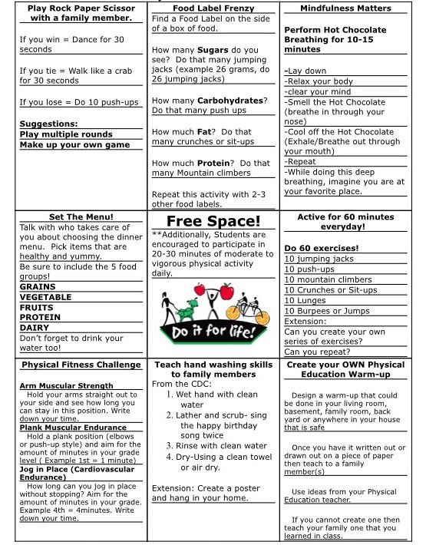

Here’s another unique way to have fun while exercising.

All you need is a coin!

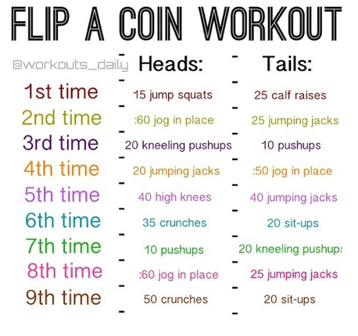

Tabata Workouts – Remember our Tabata music in PE that alternates between a fast and slow tempo. We “work” (exercise) during the fast and rest during the slow. We have done high knees and curl-ups for one of our Tabatas this year.

